Centrix Demo Architecture

We designed a secure architecture to deploy a demo Java spring boot application in AWS EC2 instance.

The configuration for this module includes a virtual private cloud (VPC) with a public subnet and a private subnet. In this module we are running a public-facing web application, while maintaining back-end servers that aren't publicly accessible.

we are creating 1 VPC, two subnets (Public and Private), 1 Internet gateway, 2 security groups, In addition, we will create Custom Route Tables and associate them with subnets with NAT gateway support.

The following diagram Architecture of the configuration for this module:

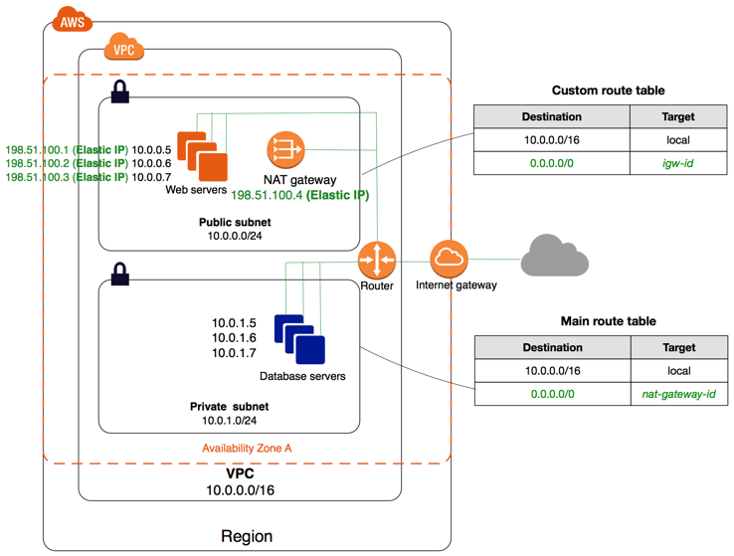

The network diagram above is the best demonstration of what’ll be implemented:

* The private subnet is inaccessible to the internet (both in and out).
* The public subnet is accessible, just dependent on the configuration of the security groups. Elastic IPs can be associated with instances in here.
* Instances in the public subnet can access instances in the private subnet because they’re in the same VPC (this is enabled by the route tables).
* Routing is handled like this:
  + Private subnet is routed through the NAT instance.
  + Public subnet is routed directly to the internet gateway.
* SSH port is blocked for the Application Ec2 instance and should be done through a bastion host deployed in public subnet.